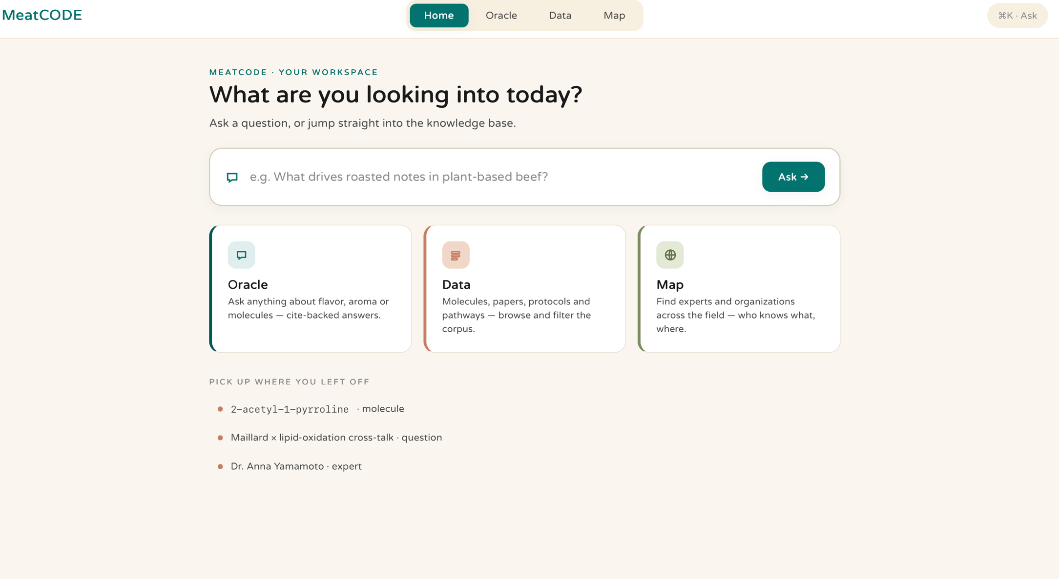
Big Inventory button that previews saved items: articles, protocls, saved chat sentences.
-make 2 versions and show them to me before adding and connecting them finally to server
-after clicked - > proceeds to the oracle chat with the exact question already submitted
-clickable
- proceeds to the given module
-no need for the map, instead put simulate
Last clicked and used chats, molecules, protocols – no need for experts.
-make sure they are clickable -> each proceeds into a page in the database that would look like this
Microphone icon that dictates recorded words in english

